Form 3803
Rev. 04/2016 | 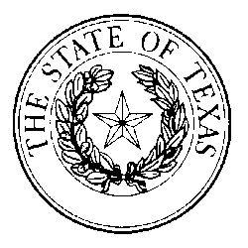  DENTAL SUPPORT ORGANIZATION  OWNERSHIP INFORMATION  ADDENDUM | This space reserved for office use only
Submit to:  SECRETARY OF STATE  Registrations Unit  P O Box 13193  Austin, TX 78711-3193  512-475-0775 |  | This space reserved for office use only

Include with the Dental Support Organization Registration when number of owners exceeds space provided.
Name: |  |  | Dentist Owner: |  |  | Non-Dentist Owner:
Business Address (Please include street address or P.O. box, city, state and zip code):
Name: |  |  | Dentist Owner: |  | Non-Dentist Owner:
Business Address (Please include street address or P.O. box, city, state and zip code):
Name: |  |  | Dentist Owner: |  | Non-Dentist Owner:
Business Address (Please include street address or P.O. box, city, state and zip code):
Name: |  | Dentist Owner: |  | Non-Dentist Owner:
Business Address (Please include street address or P.O. box, city, state and zip code):
Name: |  |  | Dentist Owner: |  |  | Non-Dentist Owner:
Business Address (Please include street address or P.O. box, city, state and zip code):
Name: |  |  | Dentist Owner: |  | Non-Dentist Owner:
Business Address (Please include street address or P.O. box, city, state and zip code):
Name: |  |  | Dentist Owner: |  | Non-Dentist Owner:
Business Address (Please include street address or P.O. box, city, state and zip code):
Name: |  |  | Dentist Owner: |  | Non-Dentist Owner:
Business Address (Please include street address or P.O. box, city, state and zip code):

