Form 3006—General Information
(Health Spa Security Exemption Application)

The attached form is designed to meet minimal statutory filing requirements pursuant to the relevant code provisions. This form and the information provided are not substitutes for the advice and services of an attorney.

Commentary

Health Spas are governed by Chapter 702 of the Texas Occupations Code (the “Health Spa Act”) and the secretary of state’s administrative rules found in 1 Texas Administrative Code Chapter 102. This form is required to apply for a security exemption under either subsection (1) or (2) of Section 702.202 of the Health Spa Act. A certificate of exemption from security will be issued upon approval of the application by the secretary of state.

Instructions for Form

- Identifying Information: The certificate holder is the person who holds the health spa registration certificate. The certificate holder’s name must match the name on the health spa registration application. The affiant is the person swearing to or affirming the contents of the application for exemption from security. The health spa is the health spa for which the security exemption is being filed.

- Reason for Exemption: You must select either A or B. Choice A describes the exemption in Section 702.202(1), while choice B describes the exemption in Section 702.202(2). If choice B is selected, the application for exemption must be resubmitted every three years.

If the circumstances of exemption stated in this form change, the certificate holder must notify the secretary of state and either: (1) file a new Security Exemption Application stating the appropriate reason for exemption; or (2) file a surety bond or certificate of deposit or post cash or its equivalent as required by subchapter D of the Health Spa Act.

- Execution: The affiant must sign and date the notice before a notary public or other official who has authority to administer an oath.

- Delivery Instructions: The form may be mailed to Registrations Unit, P.O. Box 13193, Austin, Texas 78711-3193 or delivered to the James Earl Rudder Office Building, 1019 Brazos, 1st floor, Austin, Texas 78701.

Revised 12/2014

Form #3006 Rev. 12/2014  Submit to:  SECRETARY OF STATE  Registrations Unit  P O Box 13193  Austin, TX 78711-3193  512-475-0775  512-475-2815 – Fax  Filing Fee: None | 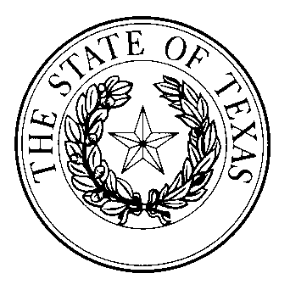  HEALTH SPA SECURITY EXEMPTION APPLICATION | This space reserved for office use

Identifying Information
Name of Certificate Holder (must match name on health spa registration application):
Name of Affiant:
Name of Health Spa:
Location of Health Spa:
Street |  |  |  |  |  |  | City |  |  | State |  |  | Zip
Reason for Exemption
You must notify the secretary of state if the reason for exemption or exemption qualification status changes.
Affiant hereby swears or affirms that Certificate Holder: (you must select either A or B below)
A. | does not require, or solicit or offer any plan or program that requires, a health spa consumer to:  - execute a membership contract for a term that exceeds 31 days;  - execute a note or a retail installment contract;  - authorize a draw or other recurring debit on a financial institution in favor of Certificate Holder or Certificate Holder’s assignee;  - pay an initiation fee or other fee, not including monthly dues; or  - prepay for a term that exceeds 31 days.
B. | - has assets based on net book value that exceeds $50,000 per registered health spa location;  - has operated under substantially the same ownership or management for at least five years; and  - has not been the subject of a complaint initiated or filed by a member of the health spa with a governmental authority in Texas relating to the closing of a health spa owned by Certificate Holder or the failure of a health spa owned by Certificate Holder to open.
Execution
Date:
 |  |  |  |  | Signature of Affiant
State of |  |  | ) |  | Printed or typed name of Affiant
County of |  |  | )
Sworn to and subscribed before me this |  |  |  |  |  | day of |  |  | , 20 |  |  | .
(seal) |  |  |  |  | Notary Public Signature

