Form #2508 Rev. 12/2011  Submit to:  SECRETARY OF STATE  Registrations Unit  P O Box 13550  Austin, TX 78711-3550  512-475-0775  512-475-2815 – Fax  Filing Fee: None. | 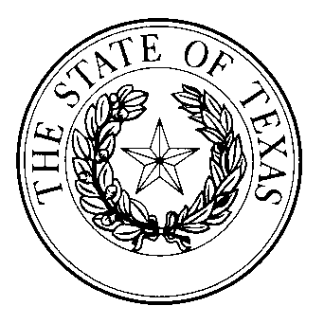  designation of compliance coordinator | This space reserved for office use

Institutions of higher education are required to designate compliance coordinators under section 2051.253(2), Texas Occupations Code, and to report the designated compliance coordinator to the secretary of state. This form is designed for use by an institution of higher education to report the designated compliance coordinator to the secretary of state.

Please also include the name and contact information for the institution’s current athletic director and email addresses for both individuals. A document on file with the secretary of state is a public record subject to public access and disclosure. The inclusion of email addresses on this form is consent for the secretary of state to use the email address for communication purposes and also consent for the secretary of state to disclose the email address to members of the public.

Finally, select the appropriate box to either confirm that implementation standards have been filed in accordance with 2051.252 or enclose a copy of the implementation standards with this form.

Institution of Higher Education
Name:
Compliance Coordinator
Name: |  |  |  |  |  |  |  | Phone:
Address:
 | Street |  |  |  |  | City |  |  |  | State | Zip
Email:
Athletic Director
Name: |  |  |  |  |  |  |  | Phone:
Address:
 | Street |  |  |  |  | City |  |  |  | State | Zip
Email:
Implementation standards have been filed with the secretary of state.
OR
Implementation standards are enclosed.
Execution
Date:
 |  |  |  |  | Signature of authorized representative for Institution of Higher Education
 |  |  |  |  | Printed or typed name and title

