Form #2103 Rev. 09/2024  Submit to:  SECRETARY OF STATE  Authentications Unit  P O Box 13550  Austin, TX 78711-3550  512-463-5705  Document Fee: $10 (up to $100 per child) | 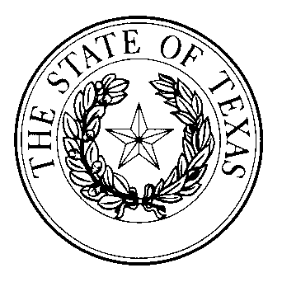  ADOPTION PROCEEDINGS—REQUEST FOR OFFICIAL CERTIFICATE OR APOSTILLE | FOR USE IN PROCEEDINGS RELATING TO THE ADOPTION OF ONE OR MORE CHILDREN

Requesting Family
Name:
Address:
 |  |  | Street |  |  |  |  |  |  |  |  |  |  |  |  |  |  | City |  |  | State |  |  | Zip
Phone: |  |  |  |  |  |  |  |  |  |  |  | Email Address:
Have you made a prior authentication request for use in the same adoption proceedings?
Yes |  |  |  | No |  |  | If YES, Customer ID Number:
Number of Children Adopting: |  |  |  |  |  |  |  |  |  | Name(s):
Consulate/Embassy/Country Where Document(s) Will Be Presented:
For Certified Records
Type of Record:
For Notarized Documents
Name of Notary:
Date Commission Expires: |  |  |  |  |  |  |  |  |  |  |  |  | Number of Certificates/Apostilles Requested:
Execution
I certify that the requested authentication(s) is(are) for use in adoption proceedings for one or more children.
Date:
 |  |  |  |  |  |  |  |  |  |  |  |  |  |  | Signature of Requestor
Instructions
- Fee. The fee for an official certificate or apostille for use in a proceeding relating to the adoption of one or more children is $10 per certificate or apostille up to $100 per child. Fees may be paid by personal checks, money orders, or American Express, Discover, MasterCard, and Visa credit cards. Checks or money orders must be payable through a U.S. bank or financial institution and made payable to the secretary of state. If paying by credit card, fees are subject to a statutorily authorized convenience fee of 2.7 percent of the total fees, and Form 2101 must also be included.

- Multiple Requests. When requesting two or more certificates or apostilles, remit one payment for the total amount. You must complete a separate form for each public official or notary public.

- Materials and Return of Documents. The complete, original, certified record or notarized document to be authenticated must be submitted with this form. If the authentication request concerns a translation, the complete document includes both the notarized translation and the document being translated. The document, fees, and form must be submitted with an appropriately sized self-addressed, postage pre-paid envelope for return of documents.

- Delivery. Materials may be delivered by mail to P.O. Box 13550, Austin, Texas 78711-3550 or by overnight mail to the physical address: Secretary of State, Authentications Unit, 1019 Brazos St., Austin, TX 78701. Walk-in service is also accepted at the physical address Monday – Friday between the hours of 9:00 a.m. - 4:00 p.m.

