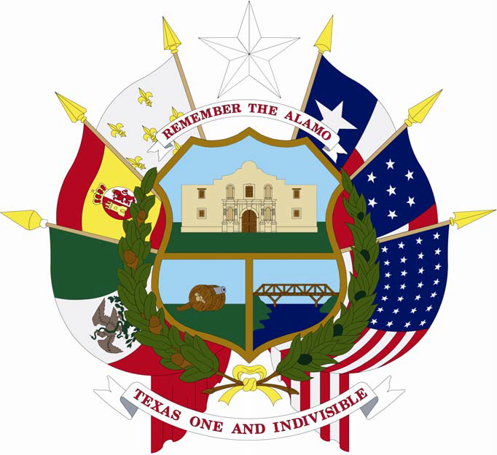

In the name and by the authority of

The State of Texas

THIS IS TO CERTIFY, that at a general election held on

Any Day, Any Month, Any Year

JOHN DOE was duly elected ANY OFFICER

In testimony whereof, I have hereunto signed my name and

caused the Seal of
to be

affixed at the City of ,

this the
day of

, 20 .

Signature of Presiding Officer of
Canvassing Authority

